**Excel and PowerBi Project**

1. **Create a PivotTable in Excel to analyze the data.**

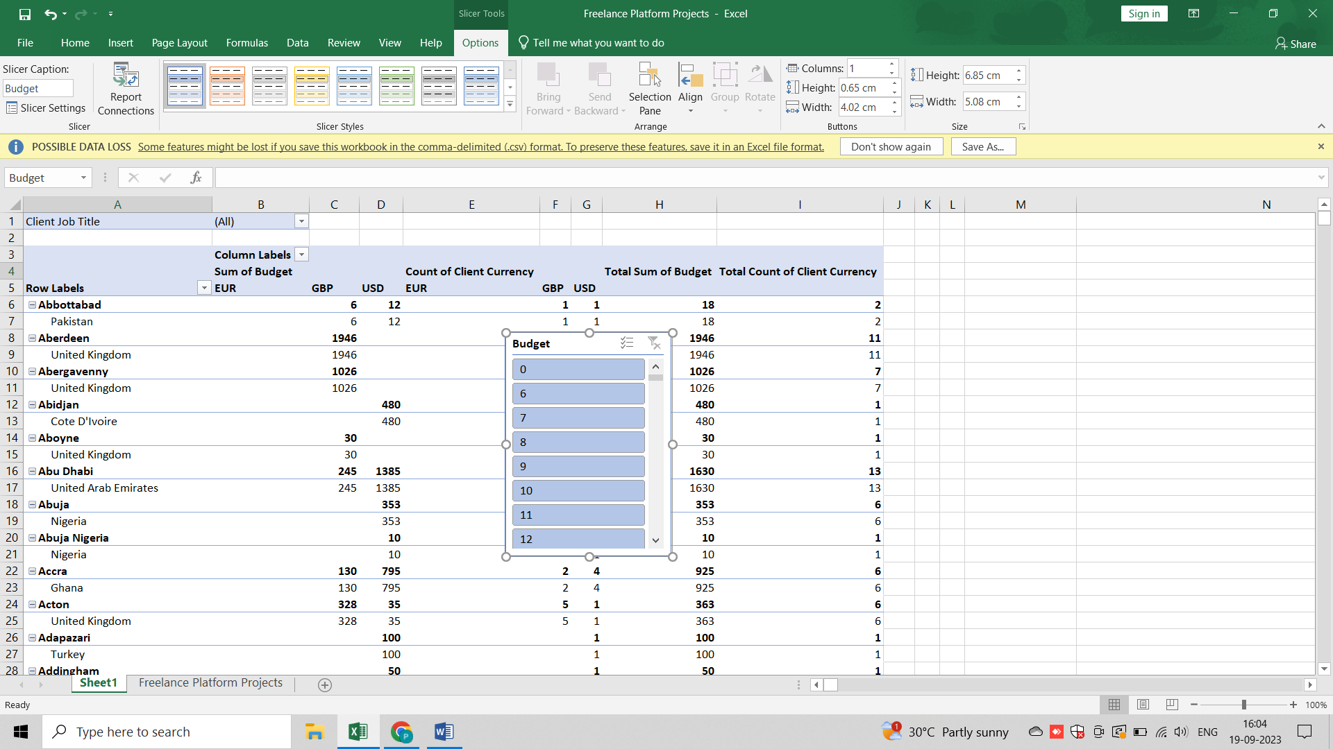

1. **Create a Pivot Chart in Excel to represent the result of analysis.**

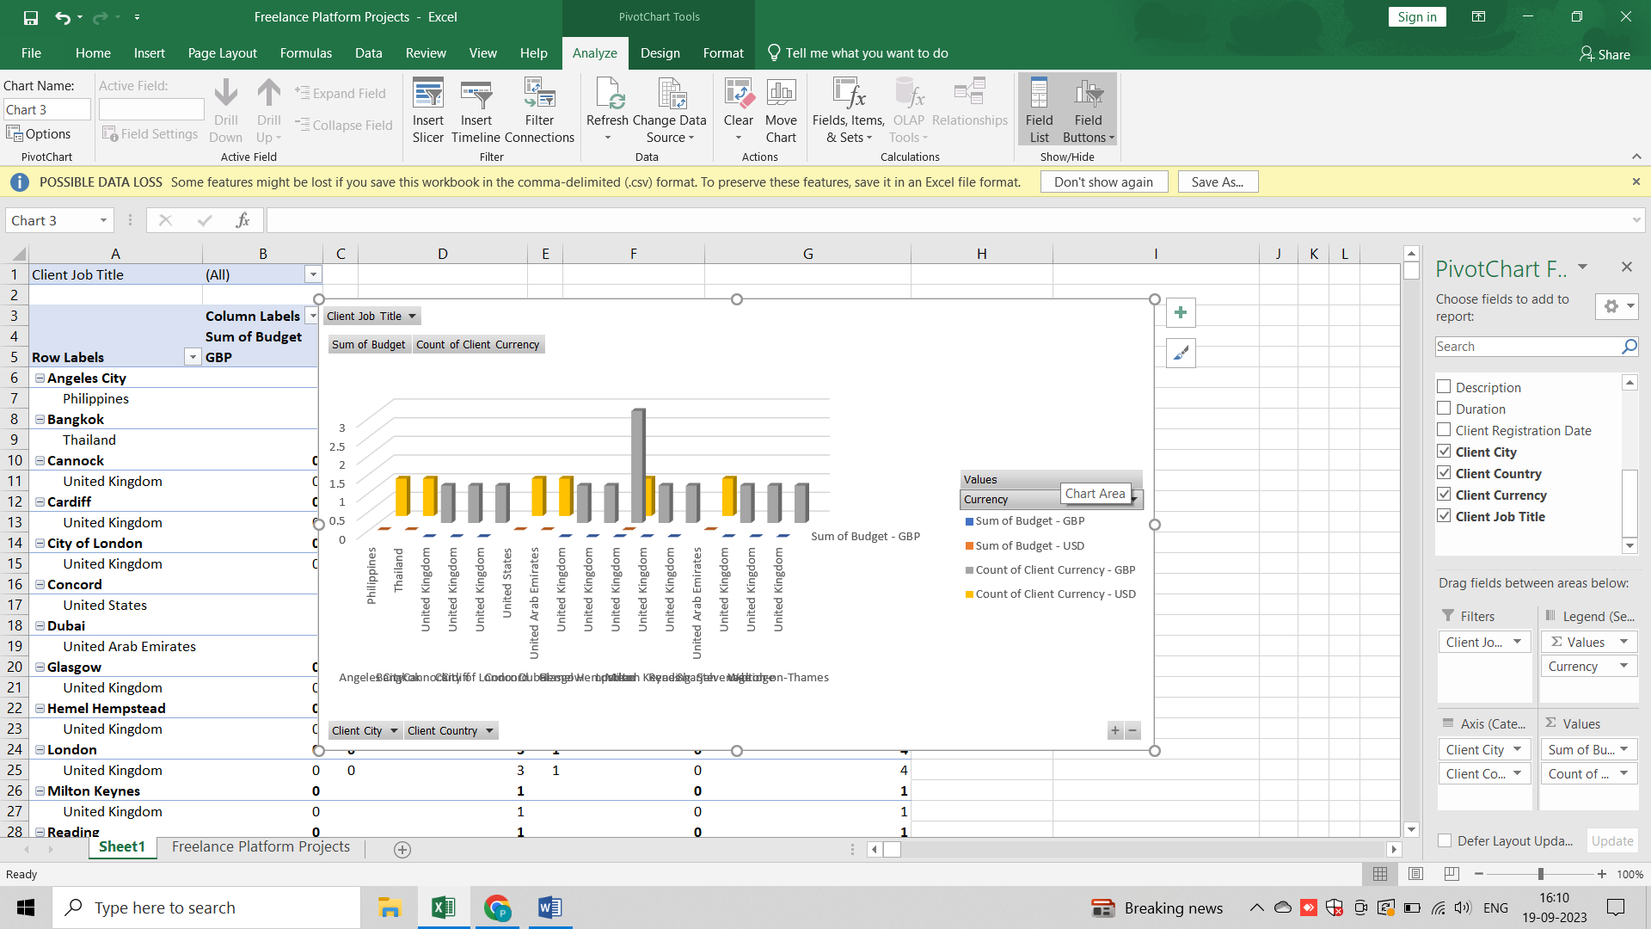

1. **Create a dashboard in Excel using the data.**

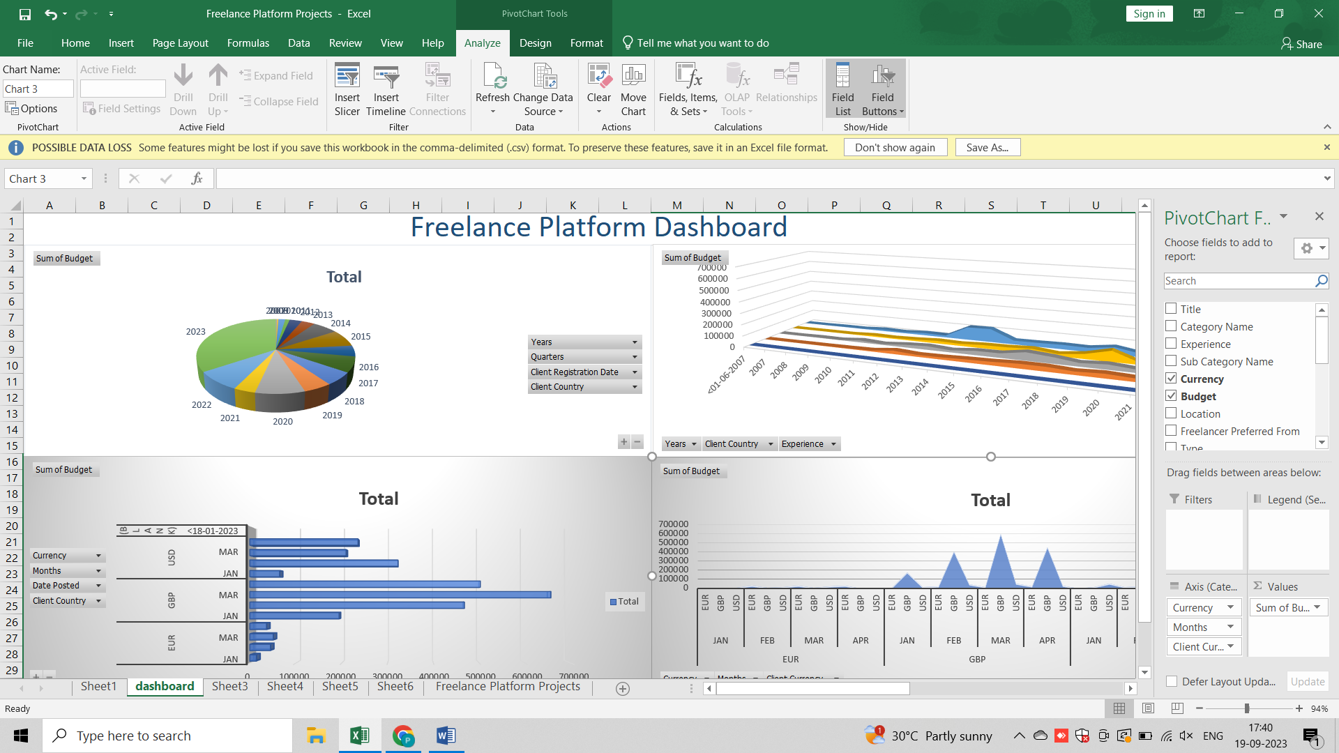

1. **Transform the data using Power Query and DAX in Power BI.**

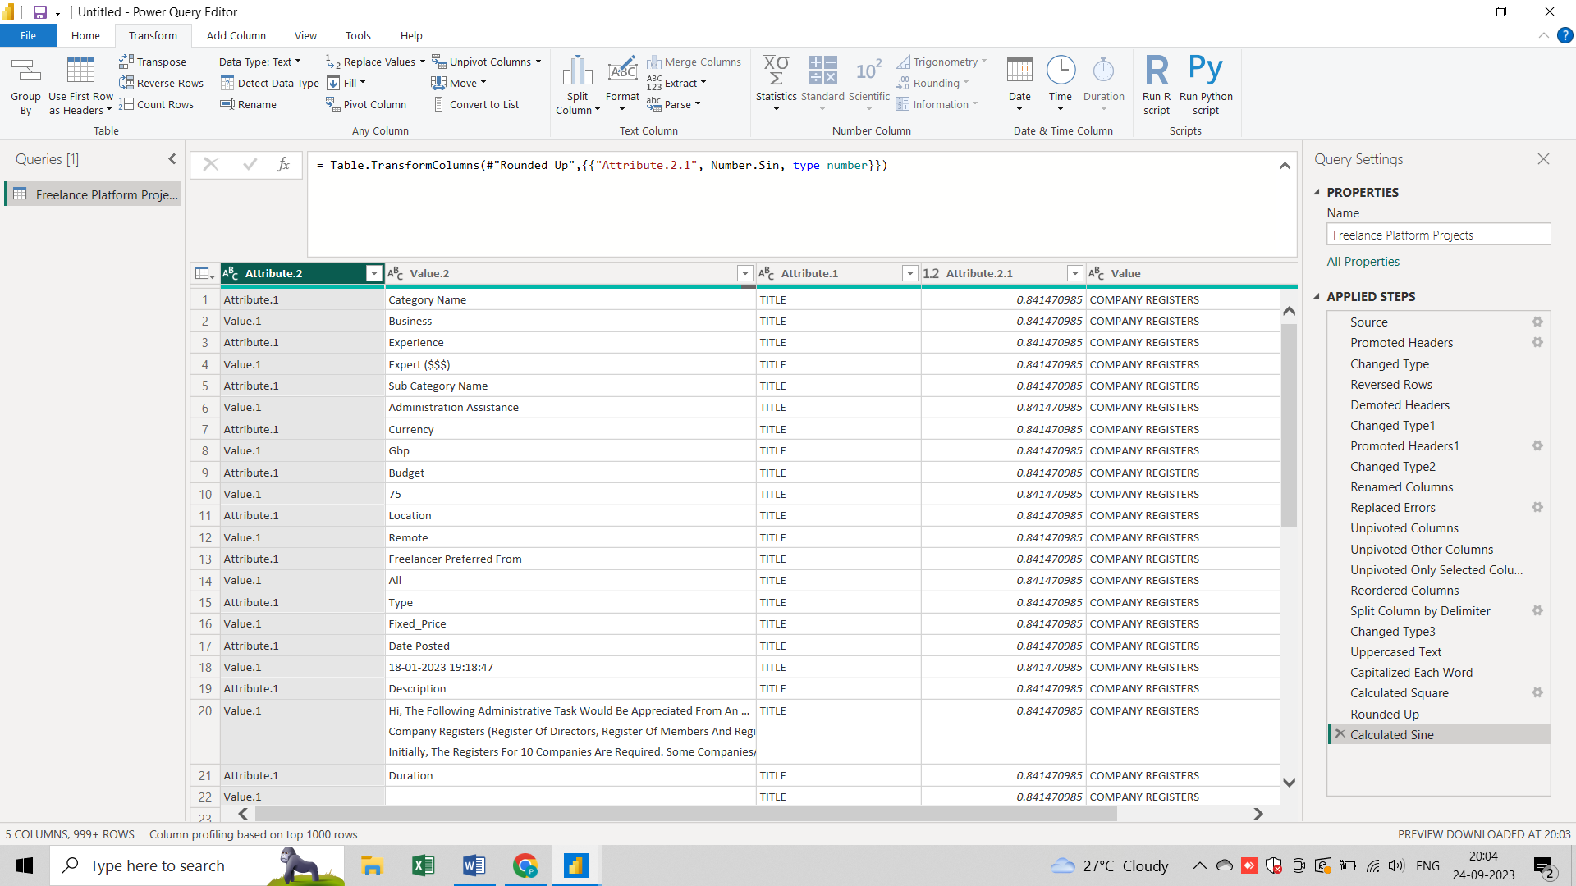

1. **Create Visualizations to analyze the data in Power BI.**

